HPE Synergy Image Streamer - Capture RHEL 7.3

Edition: 1

Published: April 2017

# Notices The information contained herein is subject to change without notice. The only warranties for Hewlett Packard Enterprise products and services are set forth in the express warranty statements accompanying such products and services. Nothing herein should be construed as constituting an additional warranty. Hewlett Packard Enterprise shall not be liable for technical or editorial errors or omissions contained herein. Confidential computer software. Valid license from Hewlett Packard Enterprise required for possession, use, or copying. Consistent with FAR 12.211 and 12.212, Commercial Computer Software, Computer Software Documentation, and Technical Data for Commercial Items are licensed to the U.S. Government under vendor's standard commercial license. Links to third-party websites take you outside the Hewlett Packard Enterprise website. Hewlett Packard Enterprise has no control over and is not responsible for information outside the Hewlett Packard Enterprise website.

# Acknowledgements

Red Hat® is a registered trademark of Red Hat, Inc. in the United States and other countries.

Red Hat® Enterprise Linux® operating system 7.3 is a registered trademark of Red Hat, Inc. in the United States and other countries.

# HPE Synergy Image Streamer – Capture RHEL 7.3

This document provides a step-by-step example of how to capture a RHEL 7.3 golden image with HPE Synergy Image Streamer that can be used with the RHEL 7.3 Image Streamer example artifacts.

HPE Synergy Image Streamer – Capture RHEL 7.3

1 Download the RHEL 7.3 .iso image

2 Add HPE Image Streamer sample artifacts

3 Prepare compute module for RHEL 7.3 installation

4 Create a Server Profile with an empty OS volume

5 Install RHEL 7.3 to the empty OS Volume

6 Capture the Golden Image from the Installed Volume

7 Congratulations!

## Download the RHEL 7.3 .iso image

### Obtain RHEL 7.3 .iso image.

Download the RHEL 7.3 server install .iso image to the same system where the web browser running HPE OneView on the HPE Synergy Composer is running.

## Add HPE Image Streamer sample artifacts

### Download artifacts from the HPE GitHub site.

Download the image-streamer-rhel RHEL-7.3 sample artifact bundle:

<https://github.com/HewlettPackard/image-streamer-rhel/tree/master/artifact-bundles>

Download the image-streamer-tools-foundation sample artifact bundle if it is not already added to HPE Image Streamer:

<https://github.com/HewlettPackard/image-streamer-tools/tree/master/foundation/artifact-bundles>

### Add artifact bundles to HPE Image Streamer

Navigate to the HPE Image Streamer Artifact Bundles page.

Use Add artifact bundle to load the previously downloaded bundles.

Use the Extract Action to on each artifact bundle to extract their artifacts.

# Prepare compute module for RHEL 7.3 installation

There are many viable means to install RHEL 7.3 on to the compute module which will be used to capture the golden image. In this example HPE iLO virtual media will be used to mount the RHEL 7.3 .iso server install image to the compute module.

### Attach RHEL 7.3 .iso to compute module

Select the Server Hardware to be used to create the RHEL 7.3 golden image.

Select Launch console from the Actions menu to launch the iLO Remote Console.

### Mount the RHEL 7.3 .iso image with iLO Virtual Media

On the iLO Integrated Remote Console menu select Virtual Drives.

Use the “Image File CD-ROM/DVD” option to locate and Open the RHEL-7.3 .iso image previously downloaded.

## Create a Server Profile with an empty OS volume

### Start creation of a Server Profile

Select Create profile in the Hardware section of the page.

### Specify Server Profile settings

### Give the Server Profile a name

Type a name for the Server Profile in the Name field.

### Specify an OS Deployment plan

Use the dropdown box to select:

HPE – Foundation – create empty OS volume

The plan name may include version number details not shown here.

### Modify deployment settings

Enter a volume size for the golden image.

While HPE Image Streamer uses thin provisioning for all storage volumes this will be the maximum size the volumes deployed from this golden image can achieve.

In this example 20000 MiB (20 GiB) is used.

### Complete Creation of Server Profile

Select Create to complete server profile creation.

Once Create is selected OS Deployment will begin as an early step in the Server Profile create process. OS Deployment will typically be completed in 15 seconds. Additional Server Profile work is needed to complete server provisioning. The Server Profile create process will take a several minutes depending on the configuration work to be done.

## Install RHEL 7.3 to the empty OS Volume

### Power on the server

Select Power on from the Actions menu.

### Modify the install kernel parameters

The RHEL 7.3 install kernel will not recognize the HPE Image Streamer iSCSI empty OS volume by default. The kernel parameter “rd.iscsi.ibft=1” needs to be added to tell the kernel to get the OS volume iSCSI configuration parameters from the compute module firmware set by the Server Profile.

Using the iLO Remote Console once the RedHat 7.3 boot loader screen appears:

### Select install boot option to edit

Select desired install option.

Press the “e” key to edit.

### Add the rd.iscsi.ibft=1 install kernel boot parameter

Modify the install kernel vmlinuz line by adding rd.iscsi.ibft=1 at the end.

### Continue the install kernel boot process

Press Ctrl-x to start.

### Set the installation configuration parameters

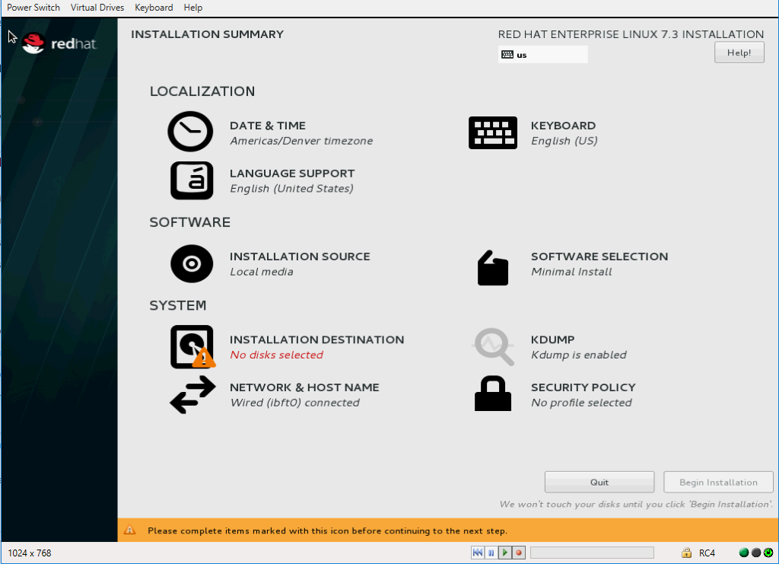When the installer starts, set the local language and proceed to the Installation Summary page.

Since this installation is going to be used to create a golden image, choices made here will become part of every boot/root volume deployed when using this golden image in the OS Deployment process.

### For Localization:

Set Date & Time (timezone), Keyboard and Language Support as desired for the golden image.

### For Software:

When using iLO Virtual Media as in this example leave the setting as Local media.

Add additional Software as desired to be in every boot/run volume deployed from this golden image.

### For System:

It is recommended to not make changes to Network and Host name settings as these are usually set in the HPE Image Streamer OS Deployment personalization process.

The rd.iscsi.ibft=1 parameter added as an option to the install boot kernel resulted in the iSCSI connection to the deployed empty volume being automatically configured.

Set kdump and Security policy as desired for the golden image.

Finally, click on Installation Destination and proceed to the next step.

**Note:** Use only one of the following two sections:

Select installation device – Servers without local or DAS storage

Select installation device – Servers with local or DAS storage

It is recommended to disconnect any local or remote DAS (Direct Attached Storage via D3940) or SAN (Storage Area Network) storage connected to the compute module prior to capturing a golden image. This storage will generally be configured when compute modules are provisioned during Server Profile provisioning and configured by the artifacts in the HPE Image Streamer OS Deployment personalization process.

### Select installation device – Servers without local or DAS storage

The empty OS volume for installation to create the golden image will be in the Specialized & Network Disks as:

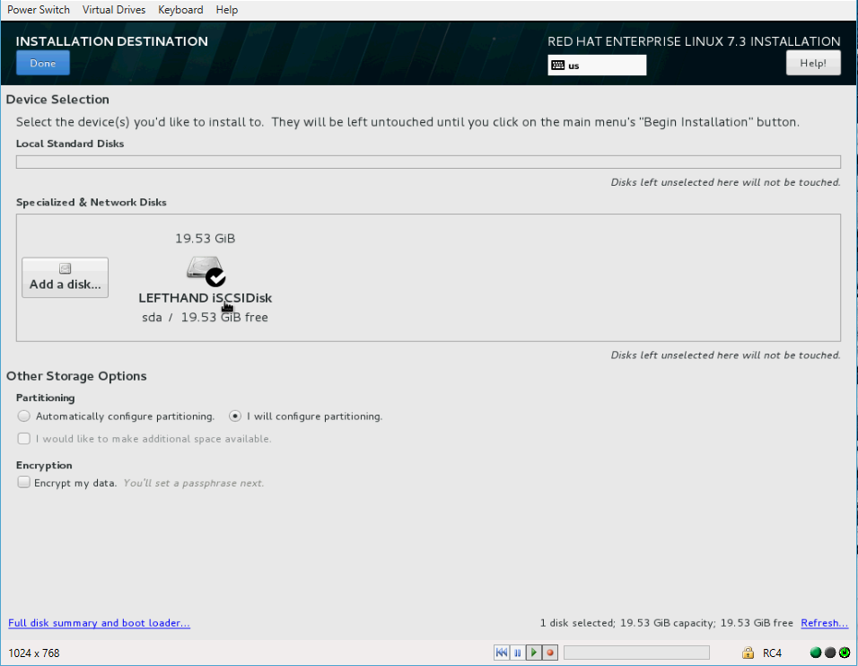LEFTHAND iSCSIDisk

### Specialized and Network Drives

Select the LEFTHAND iSCSIDisk if not already selected by default.

### Partitioning

Select the “I will configure partitioning option”

### Encryption

Set encryption as desired.

#### Proceed to:

Configure partitions for the HPE Image Streamer empty volume

### Select installation device – Servers with local or DAS storage

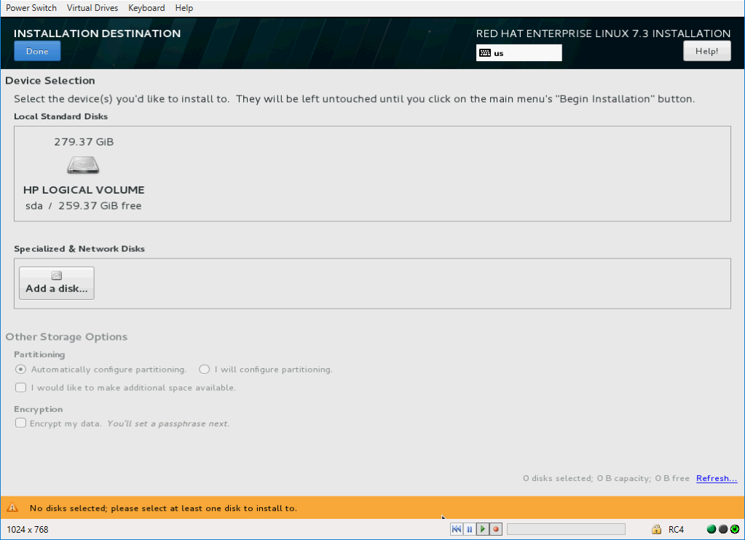When local attached or DAS (Direct Attached Storage via D3950) is present the Installation Destination will generally list it by default and the iSCSI OS Volume deployed by HPE Image Streamer will need to be added as a Specialized & Networked Disk.

#### Specialized and Network Drives

Select Add a disk…

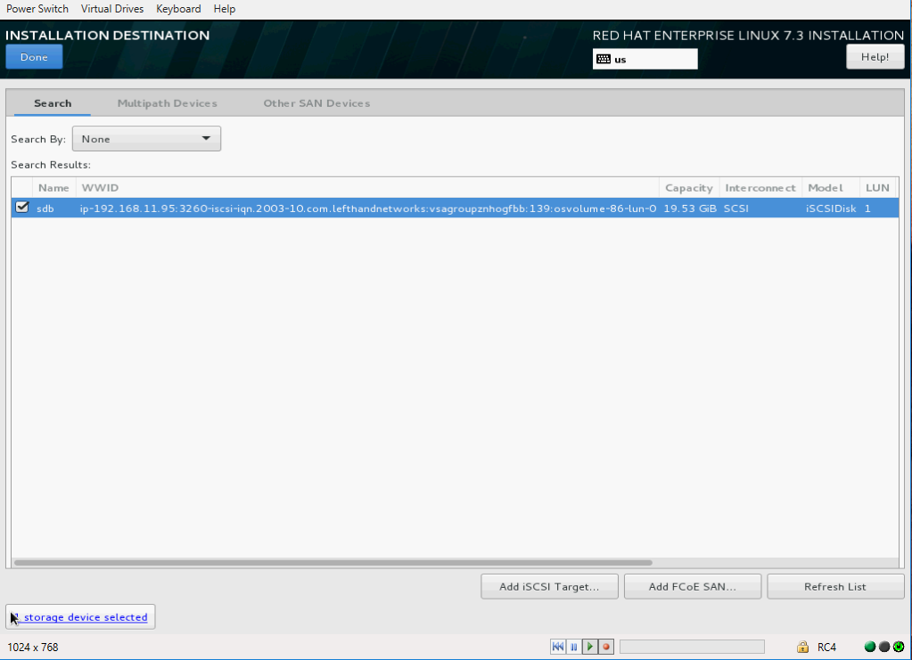

### Select the empty OS volume

Check the box with the lefthandnetworks WWID.

Select Done.

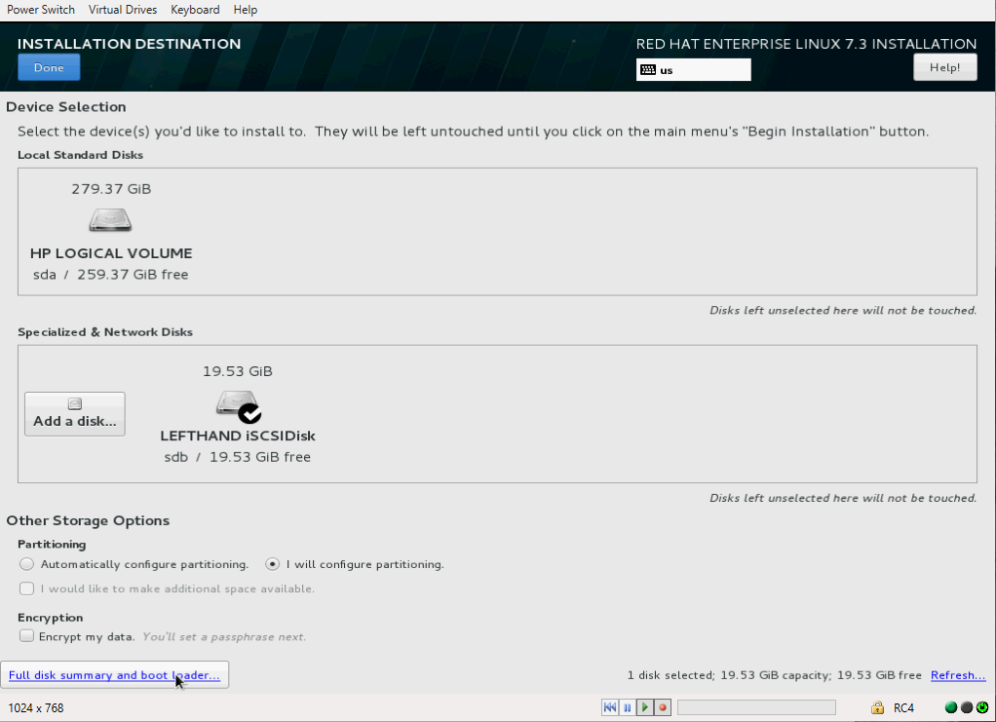

#### Specialized and Network Drives

Select the LEFTHAND iSCSIDisk if not already selected by default.

### Partitioning

Select the “I will configure partitioning option”.

### Encryption

Set encryption if desired.

Select Done.

#### Proceed to:

Configure partitions for the HPE Image Streamer empty volume

### Configure partitions for the HPE Image Streamer empty volume

Create partitions as desired for the empty boot/run volume. Using LVM on one or a small number of partitions could provide flexibility to configure volumes for various applications later when creating the OS-application images that will ultimately be deployed and updated using HPE Image Streamer enabled lifecycle processes.

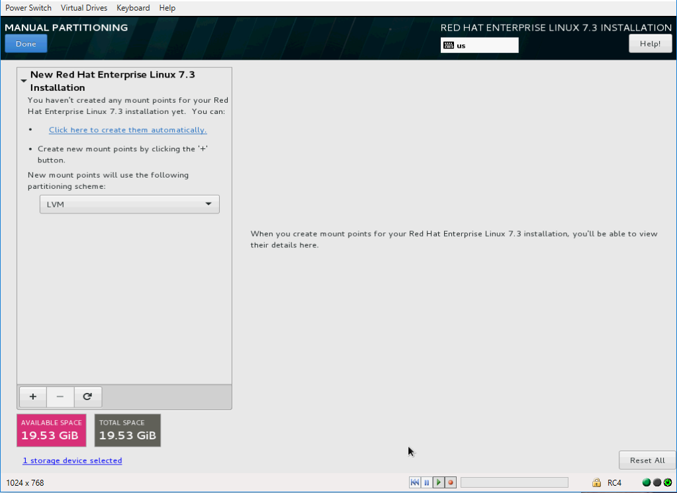**Note:** At this time only ext3 and ext4 files systems can be used during the HPE Image Streamer boot/run personalization process of Linux OSs. RHEL 7.3 defaults partitions to use the xfs file system so be sure to change added partitions to ext3 or ext4 (this does not apply to the /boot/efi or swap partitions).

#### Create partitions:

In this example “Click here to create them automatically” was selected.

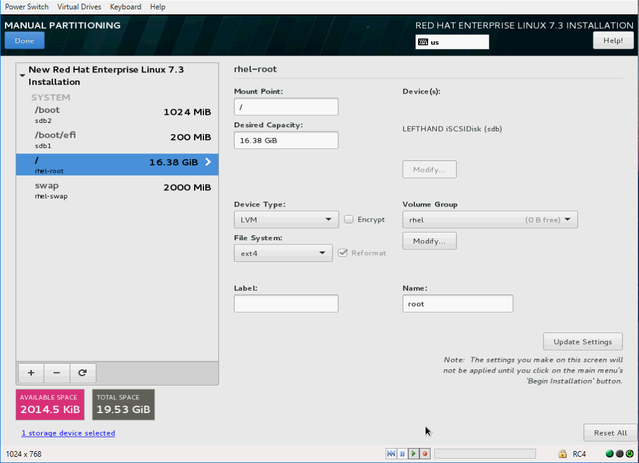

#### Change the / and /boot partition file systems

In this example the automatically created / and /boot partitions need to be changed to ext3 or ext4. If additional partitions were created which will need to be personalized by HPE Image Streamer plan scripts, they too will need their file systems set to ext3 or ext4.

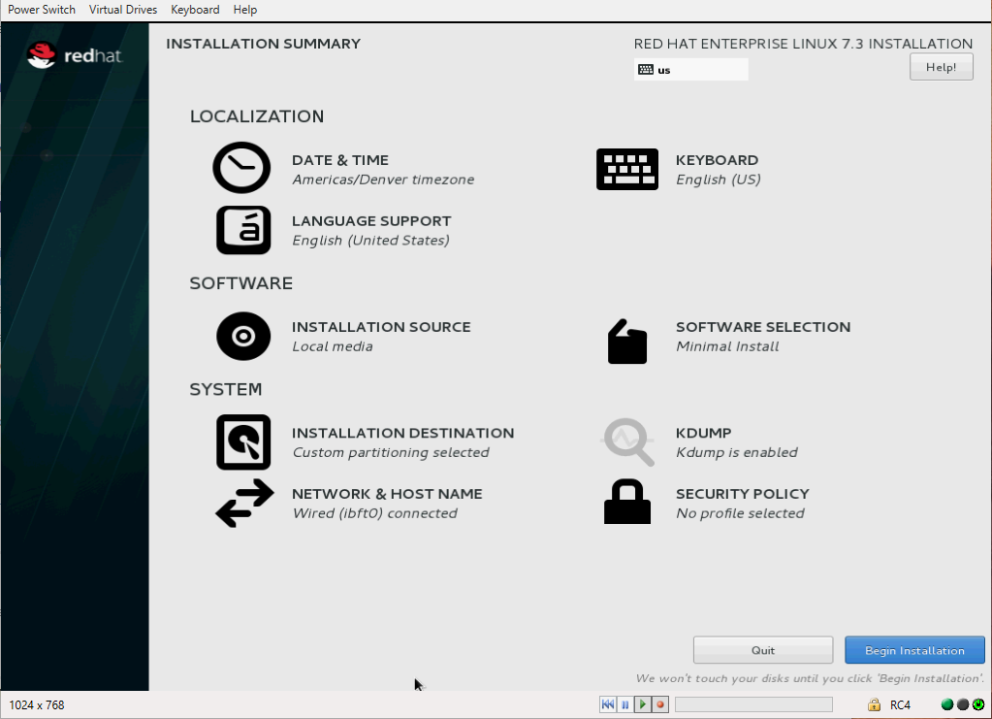

#### When partitioning is complete:

Select Done.

#### Continue with installation:

Select Begin Installation.

### Configure User Settings and complete installation

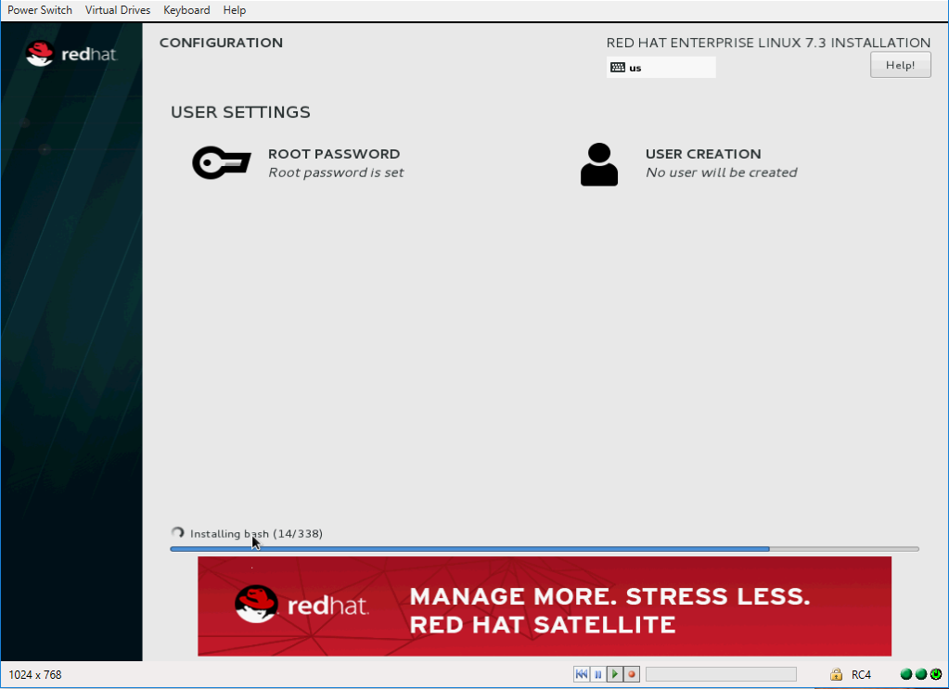Generally the personalization process for individual boot/run volumes will include setting the root password and adding users. However, to validate this base golden image is captured as intended a temporary root password should be set.

### Set the root password

Select the Root Password option.

### Finish configuration once installation is complete:

Select Reboot.

### Validate installation

Once the server has rebooted login as root and validate that all installation options have been completed as desired.

### Shut down and power off the server

Once validation is complete shutdown and power off the server. At the command line enter:

shutdown –h 0

## Capture the Golden Image from the Installed Volume

### Determine the OS volume name for the installed volume

#### Return to Server Profile page for the provisioned server

In this example the RHEL 7.3 Capture Server Profile created earlier.

Navigate to the OS Deployment section of the Server Profile.

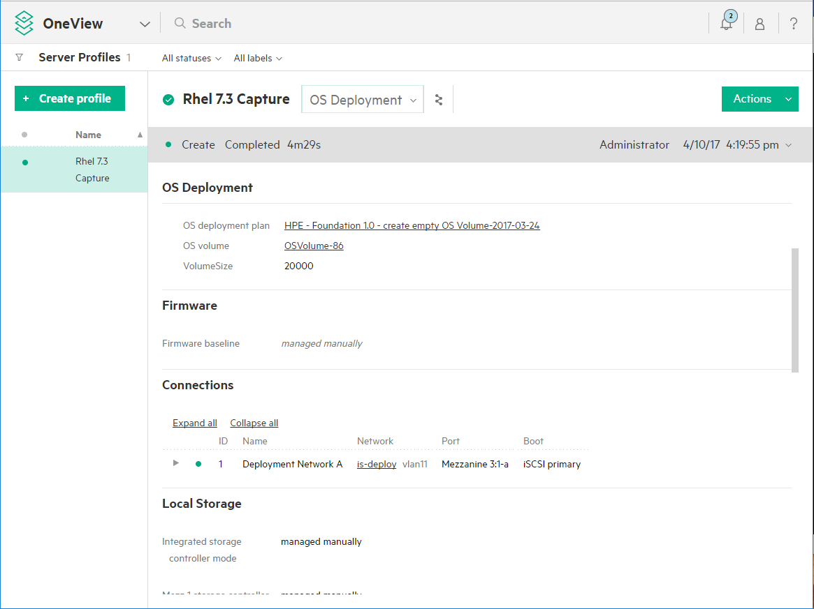

#### Note the OS Volume name which was deployed

In this example OS Volume-86.

### Capture the OS Volume

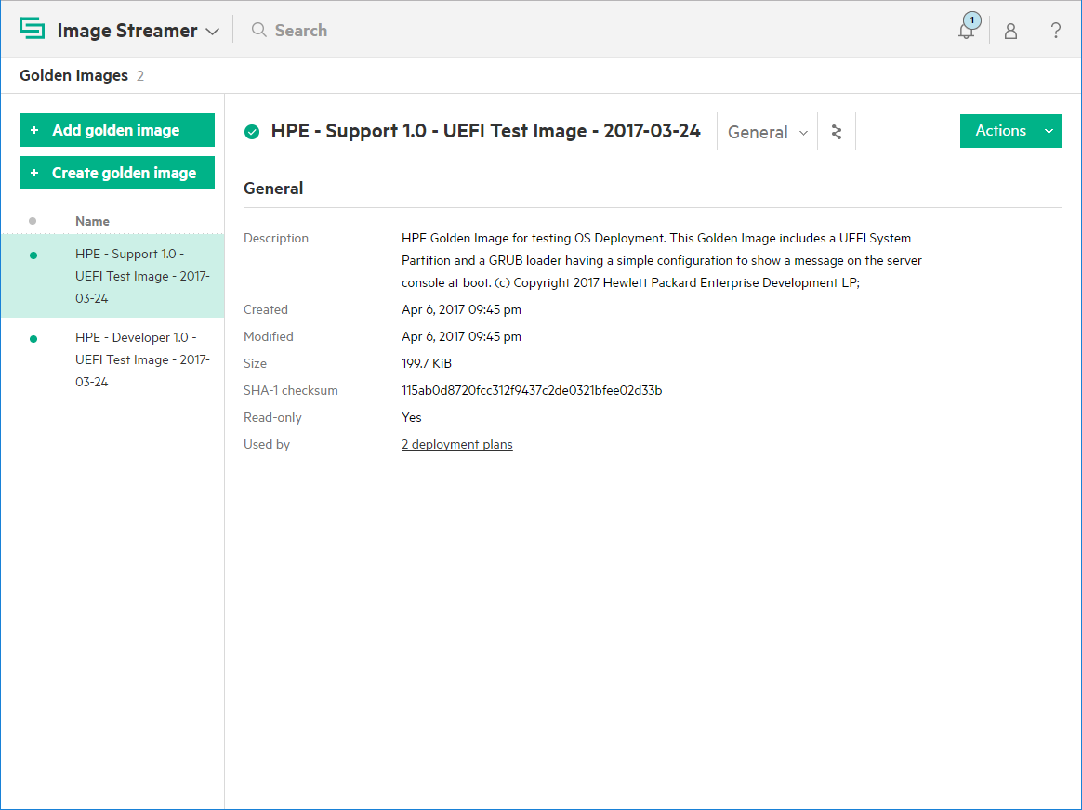Navigate to the HPE Image Streamer Golden Images page.

#### Select Create golden image

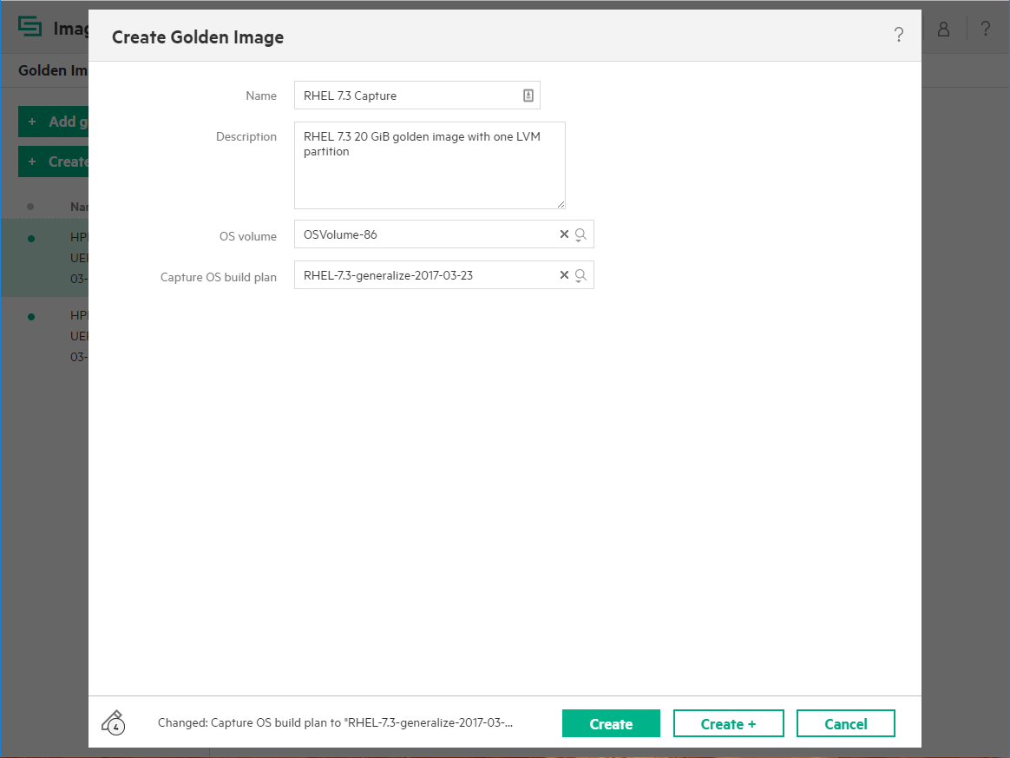

#### Specify Name and Description

Enter a Name and Description as desired.

#### Specify the OS volume

Use the dropdown box to find the OS volume previously noted.

In this example OSVolume-86

#### Specify the Capture OS build plan

Use the dropdown box to select:

RHEL-7.3-generalize

The plan name may include version number details not shown here.

#### Start the capture process

Select Create.

## Congratulations!

The golden image is now available for use in deployment plans based on RHEL 7.3.

If desired the server profile used to create the golden image can be deleted from the server hardware so the server hardware can be used for other purposes.